Template for Letters on Evolutionary Behavioral Science: Title should be Bold and in Title Case (Capitalize the First Letter of Each Major Word)

Hisashi Nakao^{1,*}, Shinya Yamamoto²

¹Nanzan University, 18 Yamazato-cho, Showa-ku, Nagoya 466-8673, Japan
²Kyoto University, 46 Yoshidashimoadachi-cho, Sakyo-ku, Kyoto 606-8501, Japan

*Author for correspondence (lebs_editor@hbesj.org)

Short title: Short titles should be in sentence case

Abstract
Manuscript must be a single MS Word file containing all graphics, tables, and an abstract. The Word file must be submitted through the editorial system at https://lebs.hbesj.org/ with a cover letter, which contains the title, short title, author’s name, affiliation, telephone and fax numbers, and electronic mail address of the corresponding author. The cover letter should contain an abstract in a text format as well as word count for the review purpose.

Keywords
Insert 3–6 keywords here. Keywords should be in lower case unless it is a proper noun or acronym (e.g., human evolution, Darwinian medicine, ESS, prisoner’s dilemma game).

Introduction
The main text should be approximately 2,500 words. This does not include a cover page, references, acknowledgments, and figure/table legends.

Methods
The style of the Publication Manual of the American Psychological Association (APA Manual; 7th Edition) must be followed with respect to handling references, footnotes, tables and figures, and abbreviations and symbols.

Lower-level headings
(1) Name of headings
Authors may create their own heading as necessary. Headings should be in sentence case.

(2) Format of headings
Note that LEBS does not use the APA 7th ed. style headings. When making lower-level headings, follow the styles shown here.

Results
Each table and figure should be embedded within the text after its first callout. Alternatively, tables and figures may be placed on separate pages after the reference list.

Discussion
For in-text citations, follow the APA 7th ed. style. For a work with one or two authors, include the surname(s) of the author(s) in every citation. For a work with more than three authors, include the first author’s surname only, and it must be followed by “et al.” in every citation (note that “et al.” should not be underlined).
Cite references in the text as, for example, “Hasegawa and Hiraiwa­Hasegawa (1983)” or, if in parentheses, as (Hasegawa & Hiraiwa-Hasegawa, 1983). Use lower­case letters to distinguish between two papers by the same authors in the same year (e.g. Oda, 2002a, 2002b). List multiple citations in alphabetical order (e.g. Hasegawa & Hiraiwa-Hasegawa, 1983; Nakamaru, 2006; Oda, 2001), using a semicolon to separate each reference. In the reference list, list sources in alphabetical and then chronological order according to the authors’ surnames and dates.
For papers in the course of publication, use “in press” to replace the date and give the journal name in the references. For unpublished work, please refer to Section 10.8 of the APA publication manual 7th ed.

Acknowledgments
We would like to thank Motohide Seki, Rie Toriyama, and Masahito Morita for their help. This study was financially supported by JSPS KAKENHI ######.

Author contribution
For consistency and transparency, acknowledge author contributions following the CRediT (Contributor Role Taxonomy; see https://credit.niso.org/ for the definitions of 14 contribution roles). For example:
Nakao Hisashi: Conceptualization, Data curation, Funding acquisition, Investigation, Visualization, Project administration, Writing – original draft (lead), Writing – review and editing (equal). Shinya Yamamoto: Resources, Software, Formal analysis, Supervision, Validation, Methodology, Writing – original draft (supporting), Writing – review and editing (equal).

Ethical statement
If the study made use of human or animal subjects and/or tissue, you must provide an ethics statement. The name of the approving body and the approval number/ID should be included.

Data accessibility & program code
The authors are also solicited to make all the data they used accessible in supplemental files or open-access databases. If you submit data/codes together with the main manuscript file, please write: “Electronic supplementary materials are available online.” If you are sharing the data/codes via an external website (e.g., the Open Science Framework), please provide a non-“view-only” (non-anonymized) URL here.

Supplementary material
If you submit supplementary materials together with the main manuscript file, please write: “Electronic supplementary materials are available online.” If you make the supplementary materials available on an external website (e.g., the Open Science Framework), please provide a non-“view-only” (non-anonymized) URL here.

References
Darwin, C. (1859). On the origin of species by means of natural selection. John Murray.
Gelfand, M. J., Raver, J. L., Nishii, L., Leslie, L. M., Lun, J., Lim, B. C., Duan, L., Almaliach, A., Ang, S., Arnadottir, J., Aycan, Z., Boehnke, K., Boski, P., Cabecinhas, R., Chan, D., Chhokar, J., D’Amato, A., Ferrer, M. S., Fischlmayr, I. C., . . . Yamaguchi, S. (2011). Differences between tight and loose cultures: A 33-nation study. Science, 332(6033), 1100–1104. https://doi.org/10.1126/science.1197754
Hasegawa, T., & Hiraiwa-Hasegawa, M. (1983). Opportunistic and restrictive matings among wild chimpanzees in the Mahale Mountains, Tanzania. Journal of Ethology, 1, 75–85. https://doi.org/10.1007/BF02347833
Himichi, T., Osanai, H., Goto, T., Fujita, H., Kawamura, Y., Davis, M. H., & Nomura, M. (2017). Development of a Japanese version of the interpersonal reactivity index. The Japanese Journal of Psychology, 88(1), 61–71. https://doi.org/10.4992/jjpsy.88.15218
Oda, R. (2001). Lemur vocal communication and the origin of human language. In T. Matsuzawa (Ed.), Primate origins of human cognition and behavior (pp. 115–134). Springer-Verlag.
Oda, R., Naganawa, T., Yamauchi, S., Yamagata, N., & Matsumoto-Oda, A. (2009). Altruists are trusted based on non-verbal cues. Biology Letters, 5(6), 752–754. https://doi.org/10.1098/rsbl.2009.0332
Shitara, H. (2019). Nōkō bunka fukugō keisei no kōkogaku: Nōkō no hajimari 1 [The archaeology of the formation of agricultural culture complex 1]. Yuzankaku.

Figure 1
The number of articles submitted to LEBS
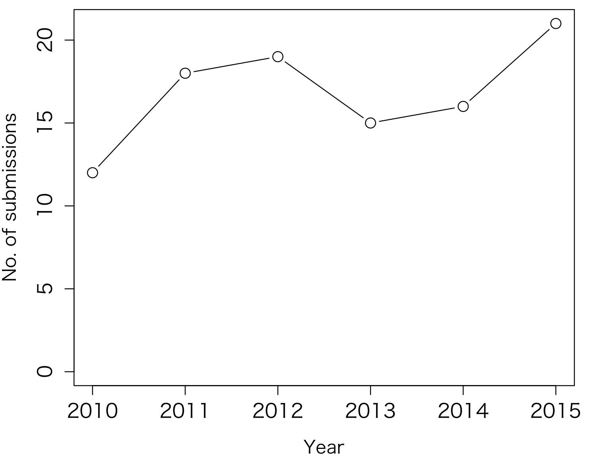
Note: A note can appear below the figure as needed.

Table 1
Table Title
Column Head | Column Head | Column Head | Column Head | Column Head
Row Head | 123 | 123 | 123 | 123
Row Head | 456 | 456 | 456 | 456
Row Head | 789 | 789 | 789 | 789
Row Head | 123 | 123 | 123 | 123
Row Head | 456 | 456 | 456 | 456
Row Head | 789 | 789 | 789 | 789

Note: A note can appear below the table as needed.

